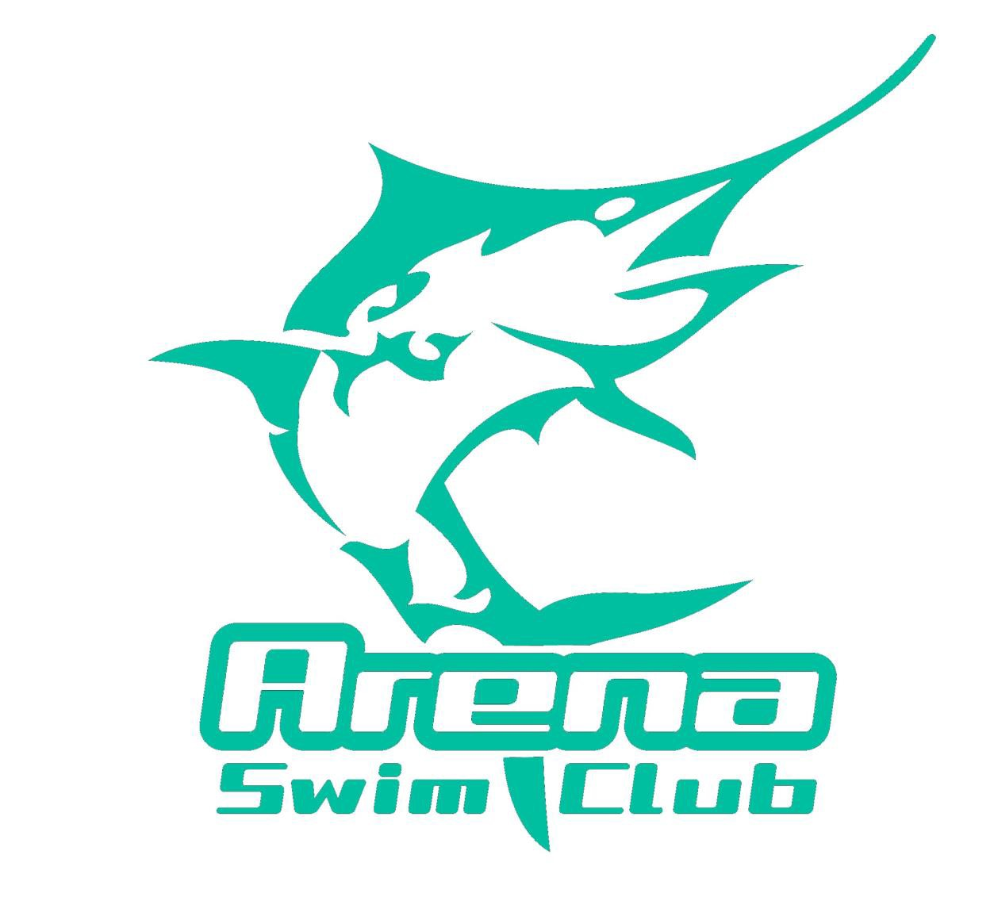
Time Keeping Roster
Swimming WA Sunsmart Long Course Qualifying Meet 2
Saturday 2nd December and Sunday 3rd December 2017
HBF Challenge Stadium

Saturday 2nd December
Warm up: 8.00am
Start Time: 9.00am
Estimated Finishing Time: 2.38pm

TIME | Accreditation
9.00am | Lotti | Jacques
10.00am | McKnight | Hewlett
11.00am | Kruger | Gastevich
12.00pm | Gloster | Tapp
1.00pm | Lummis | Burgess
2.00pm

Reserves: All Arena Swim Club Competitors

Time Keeping Roster
Swimming WA Sunsmart Long Course Qualifying Meet 2
Saturday 2nd December and Sunday 3rd December 2017
HBF Challenge Stadium

Sunday 3rd December
Warm Up: 8.00am
Start Time: 9.00am
Estimated Finishing Time: 2.32pm

TIME | LANE 5 | LANE 5
9.00am | Vorster | Loller
10.00am | Lummis | Brown
11.00am | Clouston | Janse van Rensburg
12.00pm | Rees | Prowton
1.00pm | Solly | Booth
2.00pm

Reserves: All Arena Swim Club Competitors

