Elite Technicians SWIM CLINIC
St Hilda’s Pool Jan 25th 2014
Elite Technicians Coaching at the clinic
Olympic Coach Grant Stoelwinder
2004 Australian Breaststroke Olympian Jim Piper
2004 Australian Olympic IM swimmer Adam Lucas

50m and 100m Australian Freestyle Champions
Matt Abood & Andrew Abood
Technique, Dives, Turns, Speed, race strategy, mental preparation (out of water)
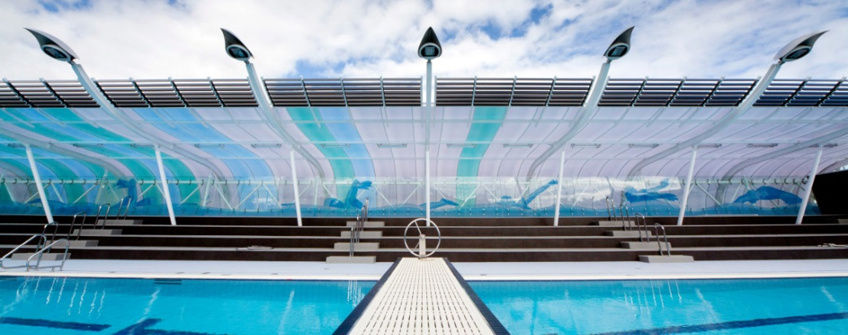

Get your technique corrected and critiqued by WA’s former Olympians
Get special advice on technique and how to race by current Australian Team members
Have your technique corrected and hear what it takes to be an Olympian by a Current Australian Team Coach
For more info or an enrolment form please Email:
Adrian.davini@sthildas.wa.edu.au

