The SunSmart Dive 'N' Try
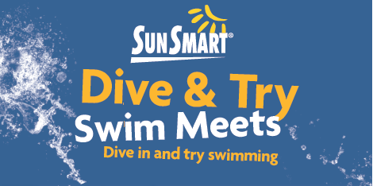
The SunSmart Dive & Try Swim Meets have been held in Western Australia for the past 41 years. The Dive & Try Swim Meets are designed to be Swimming WA's introduction to swimming competition for junior swimmers who may or may not be members of swimming clubs. The meets are designed to encourage junior swimmers in Western Australia to participate in swimming with, all swimmers being rewarded for their efforts. They are friendly, fun swim competitions with modified rules, which provide an opportunity to become involved in one of Australia's leading sports. The meets cater for 6-14 year-olds, including children with disabilities.
Preliminary meets are held at various clubs all over the State and the top 10 swimmers (eight swimmers and two reserves) from the combined club SunSmart Dive & Try Swim Meets are then selected to participate to the SunSmart Dive & Try Final to be held in May 2015.
Registration Process
The registration for all Sunsmart Dive & Try meets is electronic. No fees are payable at the time of Registration. However, each club has set an entry fee of $2.50 per event which is payable on the day of the meet. There may also be an additional cost for pool entry. Please refer to the venues program for additional details.

The following Clubs in your area are hosting a Dive & Try:
Host Date 2014 Dive and Trys Venue and Address Competitions
9-Nov-14 Kambalda Swim Club Kambalda West Aquatic Centre, Barnes Drive, Kambalda
22-Nov-14 Swan Hills Swim Club Swan Park Leisure Centre, Gray Drive, Midvale, Perth
23-Nov-14 Narrogin Swim Club (postponed) Narrogin Regional Leisure Complex, Clayton Road, Narrogin
29-Nov-14 Western Sprint Swim Club Trinity College Swimming Pool, Trinity Avenue, East Perth
7-Dec-14 Mount Barker Swim Club Mt Barker Memorial Pool, Narpund Road, Mount Barker
Host Date 2015 Dive and Trys Venue and Address Competitions
31-Jan-15 Westside Christchurch Swim Club Christchurch Grammar School Pool, Queenslea Drive, Claremont
14-Feb-15 UWA Swimming Club UWA Aquatic Centre, Parkway, Crawley
21-Feb-15 Arena Swim Club Hbf Arena Joondalup, Kennedya Drive, Joondalup
21-Feb-15 Southshore Swim Club Booragoon Leisure (Melville Aquatic Centre), Marmion St, Booragoon
22-Feb-15 Guildford & Kalamunda Guildford Grammar School, Terrace Rd Districts Swimming 28-Feb-15 Riverton Aquanauts Riverton Leisureplex, Corner of Riley & High Roads, Riverton
28-Feb-15 Rockingham Swim Club Aqua Jetty, Council Avenue, Rockingham
7-Mar-15 Breakers Swim Club Craigie Leisure Centre, Whitfords Ave., Craigie
7-Mar-15 Swan Hills Swim Club Swan Park Leisure Centre, Gray Drive, Midvale, Perth
15-Mar-15 Arena Swim Club Hbf Arena Joondalup, Kennedya Drive, Joondalup
22-Mar-15 Leisure Park Lazers Swim Club Leisure Park Balga, Princess Road, Balga
27-Mar-15 Albany Swimming Club Albany Leisure & Aquatic Centre, Barker Road, Albany
New venues will be added during the season, so if you do not find a competition time that suits your family visit us again for updated information.

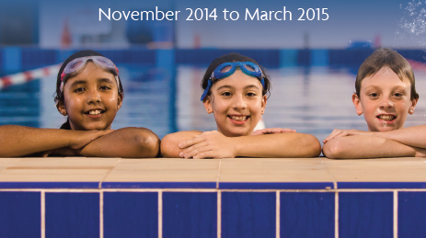
For additional information, please contact us on: 9328 4599 or email us: kate.reynolds@wa.swimming.org.au

