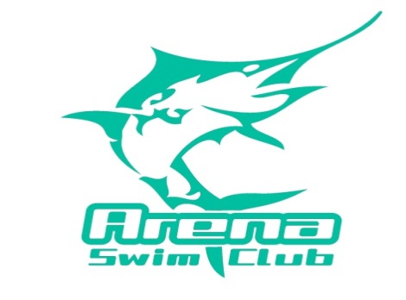
STATE QUALIFYING RACE SESSION 2 2015-2016
Friday 13 March 2015
Warm Up 5:00 Start 5:30pm – will end by 7:30pm
Entries must be in by 5:00pm on Friday 6 March 2015
Entry Fee $15.00 for 3 events
No Cash will be accepted in the office, please deposit entry fee directly into the Arena Swim Club account
No Late Entries Will Be Accepted
Mark Event | Event Number | Stroke | Mark Event | Event Number | Stroke
 | 1 | 50 Free |  | 2 | 100 Fly
 | 3 | 200 IM |  | 4 | 50 Breast
 | 5 | 200 Back |  | 6 | 200 Fly
 | 7 | 50 Back |  | 8 | 400 Free
 | 9 | 50 Fly |  | 10 | 200 Breast
 | 11 | 400 IM |  | 12 | 200 Free

NAME: DOB:
SPECIAL NOTES
- All COMPETITIVE swimmers in the club may enter.
- 50 Free open to all ages
- 50 Back, Breast and Fly (12 and under only)
- 200 IM (9 years plus)
- 400 FS (11 years plus) limited to 2 heats
- 400 IM (12 years plus) limited to 1 heat

