Race Session Raffle
Get your tickets at the uniform stand
1 ticket $3 or 2 for $5
Raffle will be drawn on Monday 20th July
1st Prize – RE Camera and accessories (value over $300)
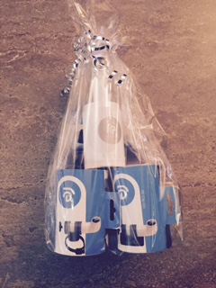
2nd Prize – Samsung Galaxy Prime
(value $199)
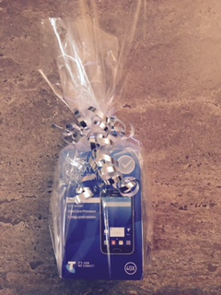
3rd Prize – Jabra Sports Headphones
(value $100)
