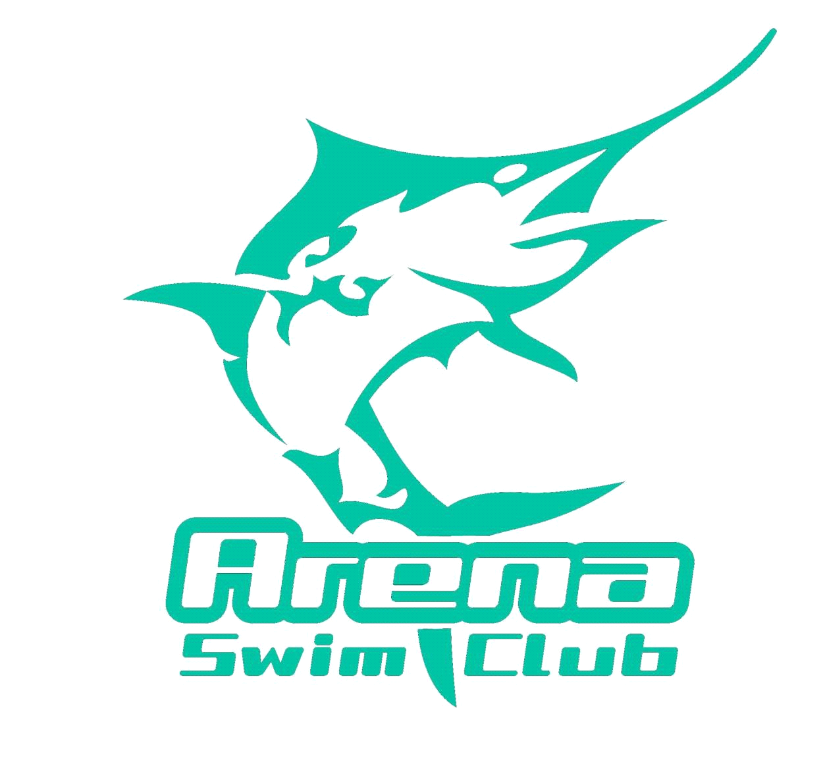

Timekeeper Roster
UWA-West Coast Short Course Challenge
Saturday 22nd July 2017
HBF Stadium Mt Claremont

Warm up: 8.00am
Start Time: 9.00am
Estimated Finishing Time: 3.03pm

Timekeeping:

TIME | LANE 7
9.00 – 10.30am | Wilson | Toms
10.30 – 12.00noon | Luyke | Quirk
12.00 – 1.30pm | Rees | Brodalka
1.30 – 3.00pm | Forrestal

Timekeeping Reserve: All Arena Swim Club Competitors

Please note that if your child is sick or unable to attend for any reason please liaise with other parents who are attending to ensure that your timekeeping duties are fulfilled as part of the terms and agreement that is agreed to when joining Arena Swim Club.

