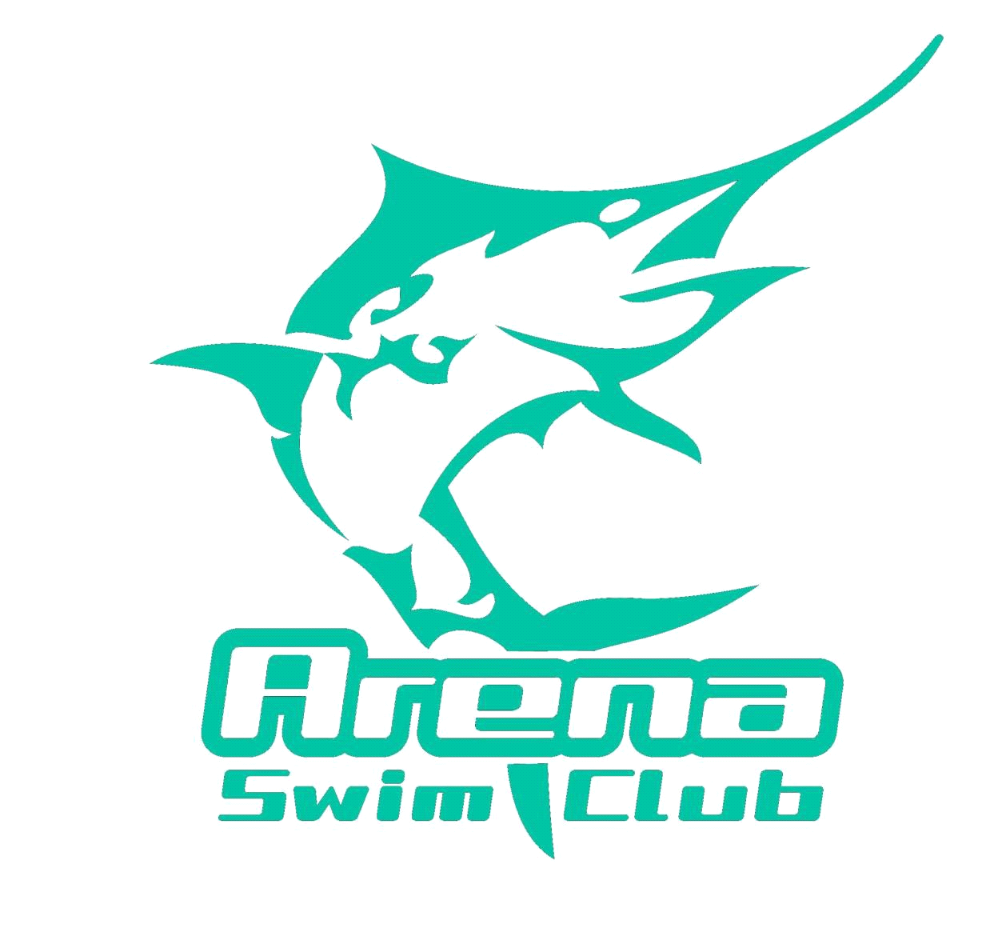

Timekeeper Roster
South Shore Super Sprint
Sunday 6th August 2017
HBF Stadium Mt Claremont

Warm up: 7.30am
Official Opening and National Anthem: 8.00am
Start Time: 8.30am
Estimated Finishing Time: 5.11pm

Timekeeping:

TIME | LANE 1
8.30 – 9.15am | Brodalka
9.15 – 10.00am | Burgess
10.00 – 10.45am | Cleaver
10.45 – 11.30am | McIntosh
11.30 – 12.15pm | Clouston
12.15 – 1.00pm | Toms

Timekeeping Reserve: All Arena Swim Club Competitors

Please note that if your child is sick or unable to attend for any reason please liaise with other parents who are attending to ensure that your timekeeping duties are fulfilled as part of the terms and agreement that is agreed to when joining Arena Swim Club.

