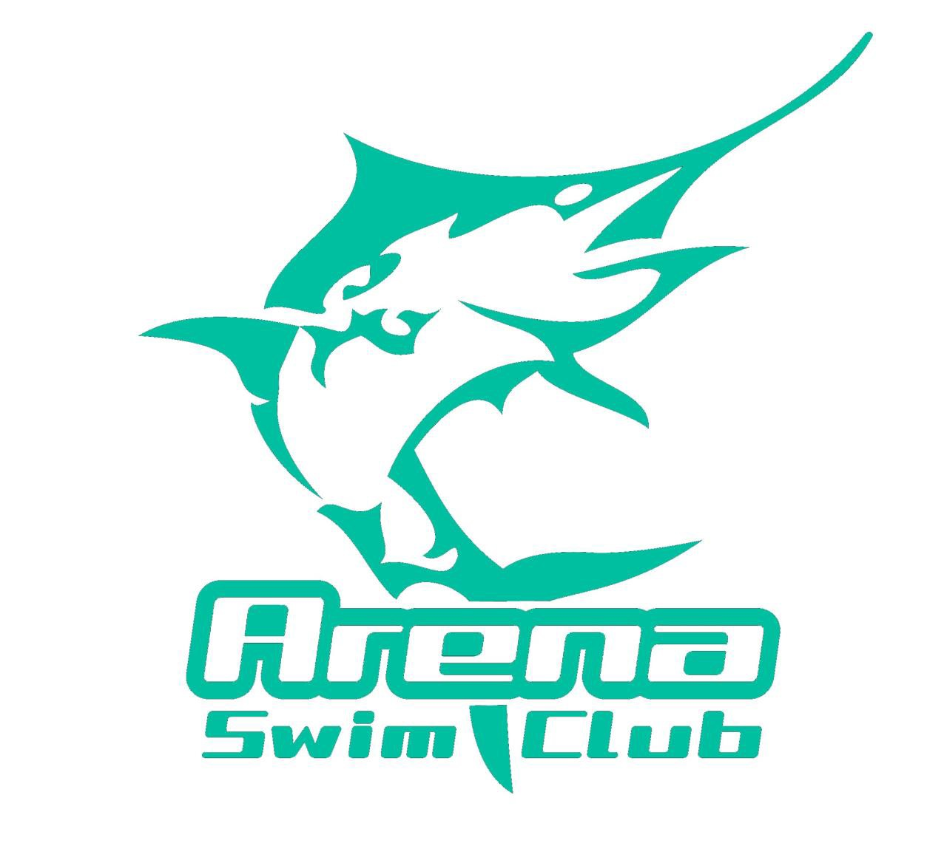
Timekeeping Roster
Swimming WA Short Course Challenge
Saturday 12th – Sunday 13th August 2017
HBF Stadium Mt Claremont

Sunday 13th August Morning Session
Warm up: 08.00am
Start Time: 09.0pm
Estimated Finishing Time: 11.45am

TIME | Lane 3
9.00 – 9.45am | Forrestal
09.45 - 10.30am | Gastevich
10.30 – 11.15am | Burgess
11.15 - 11.45am | Sivic

Reserves: All Arena Swim Club Competitors

Please note that if your child is sick or unable to attend for any reason please liaise with other parents who are attending to ensure that your timekeeping duties are fulfilled as part of the terms and agreement that is agreed to when joining Arena Swim Club

