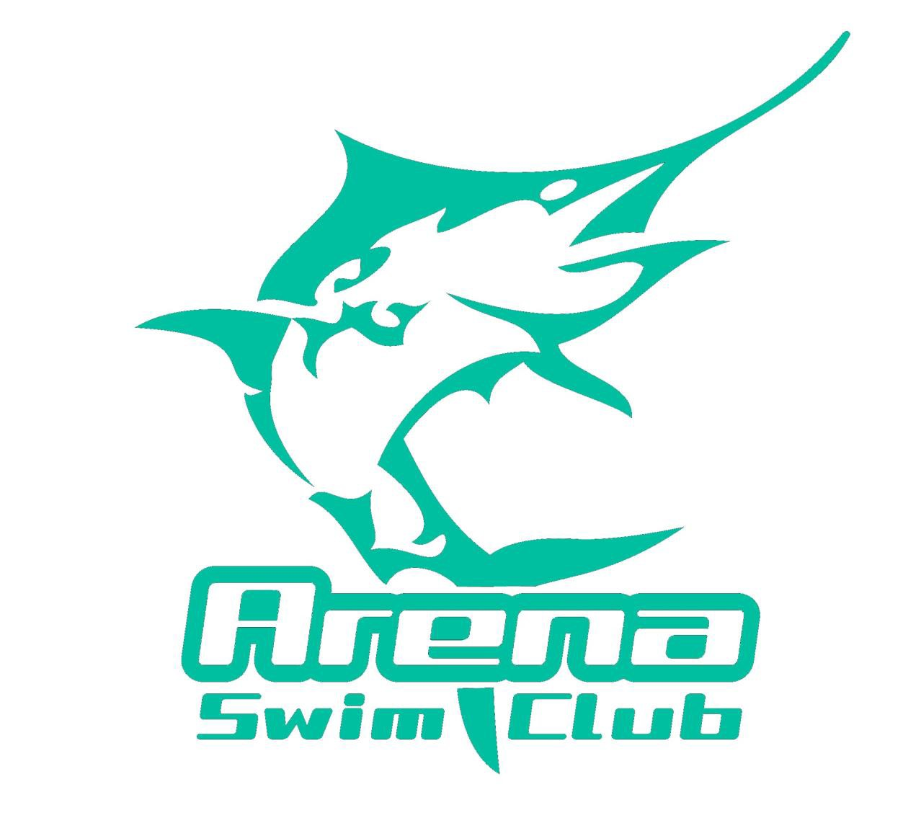
Timekeeping Roster
Swimming WA Short Course Junior Challenge
Saturday 12th – Sunday 13th August 2017
HBF Stadium Mt Claremont

Saturday 12th August
Warm up: 11.45am
Start Time: 12.30pm
Estimated Finishing Time: 4.19pm

TIME | Lane 7
12.30 - 1.30pm | Rees
1.30 - 2.30pm | Luyke
2.30 - 3.30pm | de Jesus
3.30 - 4.19pm | Salamone

Reserves: All Arena Swim Club Competitors

Sunday 13th August
Warm up: 11.45am
Start Time: 12.30pm
Estimated Finishing Time: 4.29pm

TIME | Lane 8
12.30 - 1.30pm | Wilson
1.30 - 2.30pm | Cheeseman
2.30 - 3.30pm | Bevan
3.30 - 4.29pm | Salamone

Reserves: All Arena Swim Club Competitors

Please note that if your child is sick or unable to attend for any reason please liaise with other parents who are attending to ensure that your timekeeping duties are fulfilled as part of the terms and agreement that is agreed to when joining Arena Swim Club.

